LAB EXPERIMENT RECORD
SET 6: Product Sales Analysis
Department | AI&DS
Course Code / Course Name | DSA0602 / Data Handling and Visualization
Experiment | Data Visualization using R
Name | DEVAMADA HEMASREE
Register Number | 192524114
Date | 01 OCTOBER 2026
Day | THURSDAY

SET 6: Product Sales Analysis
Aim: To visualize monthly product sales using a grouped bar chart, stacked area chart, and table in R, and to build an interactive dashboard using Tableau.
Dataset: Monthly Product Sales
Product ID | Product Name | January Sales | February Sales | March Sales
1 | Product A | 2000 | 2200 | 2400
2 | Product B | 1500 | 1800 | 1600
3 | Product C | 1200 | 1400 | 1100

PROGRAM 1: Grouped Bar Chart (Q1 Sales)
Aim: To show the sales of each product for the first quarter.
graphics.off()
sales <- matrix(c(2000, 2200, 2400,
1500, 1800, 1600,
1200, 1400, 1100), nrow = 3)
rownames(sales) <- c("January", "February", "March")
colnames(sales) <- c("Product A", "Product B", "Product C")

barplot(sales, beside = TRUE,
xlab = "Products", ylab = "Sales ($)",
main = "Q1 Sales of Each Product",
col = c("skyblue", "orange", "green"),
ylim = c(0, 3000),
legend.text = rownames(sales),
args.legend = list(title = "Month", x = "topright"))
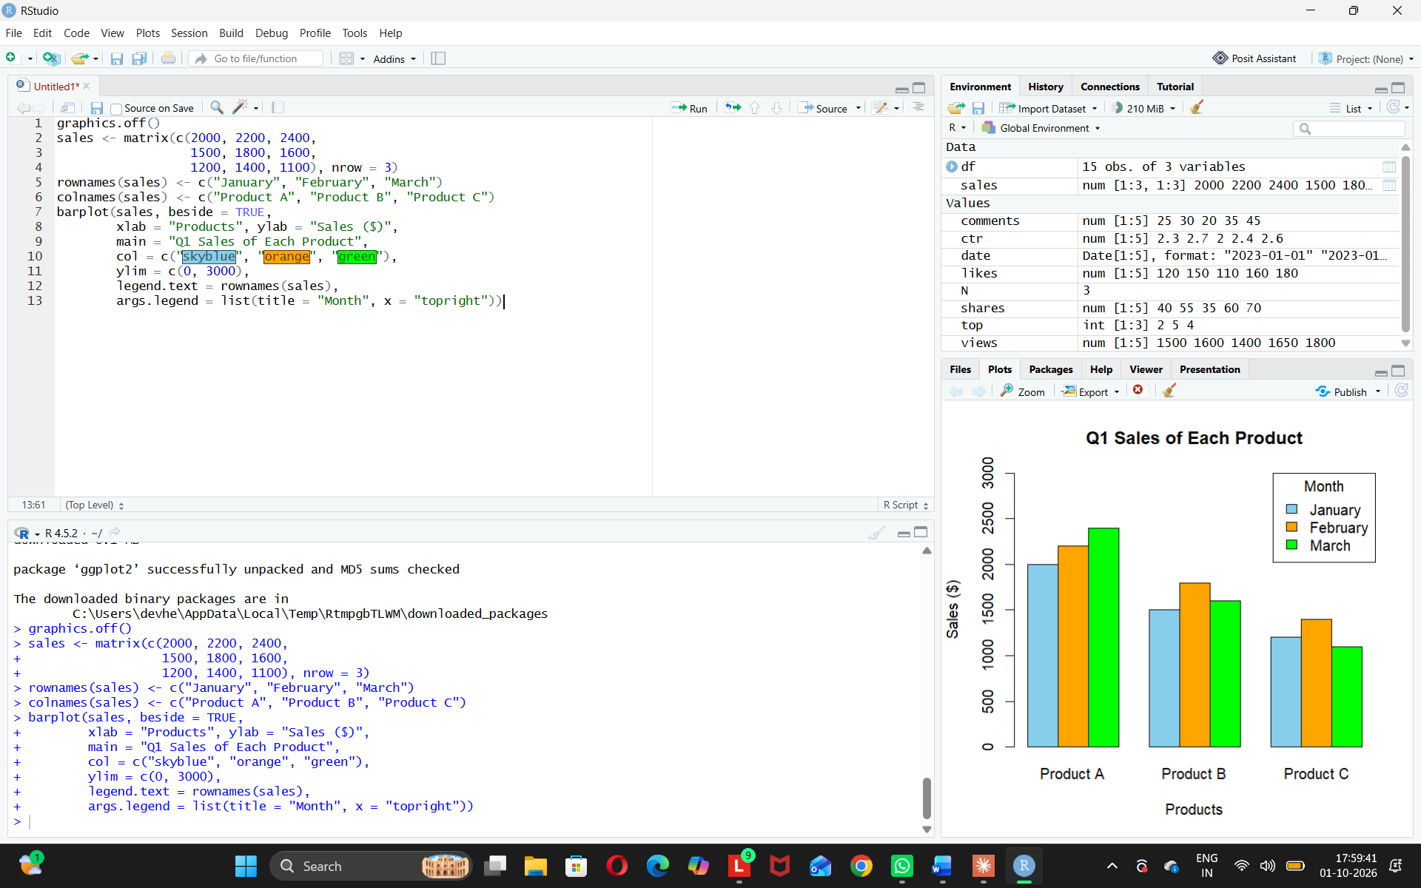
Observation: Product A has the highest sales every month. Product C has the lowest.
PROGRAM 2: Stacked Area Chart (Overall Sales Trend)
Aim: To show the overall sales trend of all products over three months.
install.packages("ggplot2") # run only once
library(ggplot2)
graphics.off()

df <- data.frame(
month = rep(1:3, 3),
product = rep(c("Product A", "Product B", "Product C"), each = 3),
sales = c(2000, 2200, 2400,
1500, 1800, 1600,
1200, 1400, 1100)
)

ggplot(df, aes(x = month, y = sales, fill = product)) +
geom_area() +
scale_x_continuous(breaks = 1:3,
labels = c("January", "February", "March")) +
labs(x = "Month", y = "Sales ($)",
title = "Overall Sales Trend", fill = "Product")
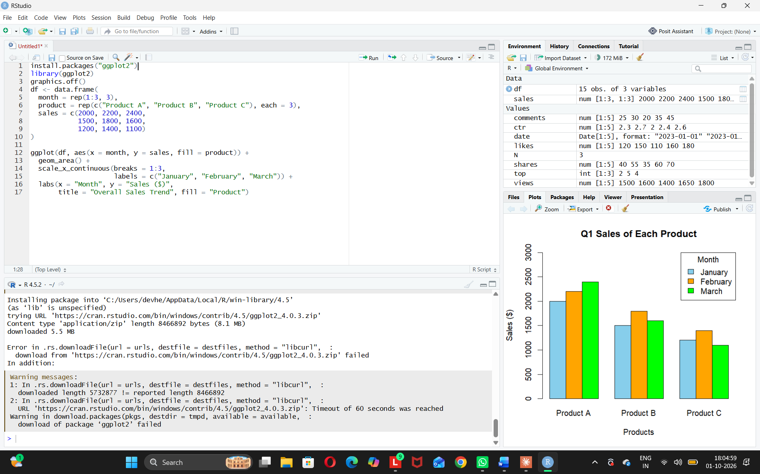
Observation: Total sales rise from January to February and dip slightly in March. Product A keeps growing.
PROGRAM 3: Table (Monthly Sales Data)
Aim: To show the monthly sales data of each product in a table.
Product_ID <- c(1, 2, 3)
Product_Name <- c("Product A", "Product B", "Product C")
January <- c(2000, 1500, 1200)
February <- c(2200, 1800, 1400)
March <- c(2400, 1600, 1100)

table_data <- data.frame(Product_ID, Product_Name,
January, February, March)
table_data$Total <- table_data$January + table_data$February + table_data$March

print(table_data)
View(table_data)
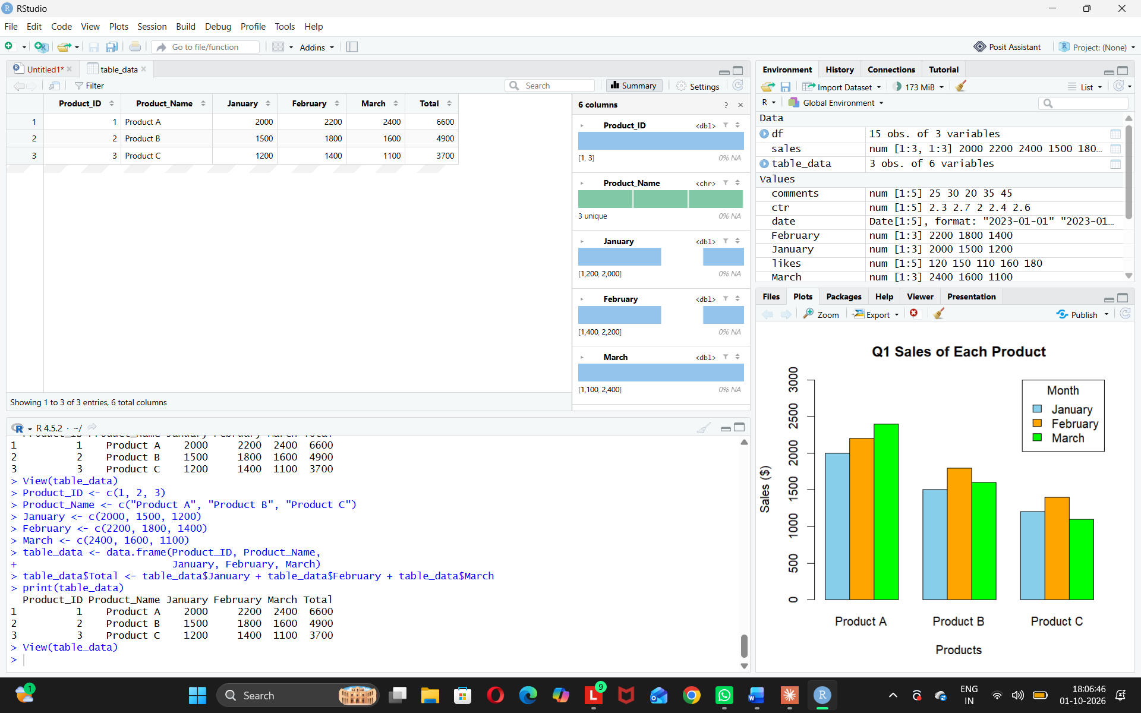
Observation: Product A has the highest total sales (6600). Product C has the lowest (3700).
PROGRAM 4: Tableau Dashboard
Aim: To build an interactive dashboard with the grouped bar chart, stacked area chart, and table in Tableau.
Steps in Tableau
1. Savethedata as an Excel or CSV file and connect to it in Tableau (Connect > Microsoft Excel / Text file). Select the January Sales, February Sales and March Sales columns, right-click and choose Pivot, then rename the newfields to "Month" and "Sales".
2. Sheet 1 (Grouped Bar Chart): Drag Product Name and then Month to Columns, and Sales to Rows (SUM). Drag Month to Color and add Sales to Label. Rename the sheet "Sales by Product".
3. Sheet 2 (Stacked Area Chart): Drag Month to Columns and Sales to Rows (SUM). Change the Marks type to Area, drag Product Name to Color, and rename the sheet "Sales Trend".
4. Sheet 3 (Table): Drag Product Name to Rows, Month to Columns and Sales to Text. Use Analysis > Totals > Show Row GrandTotals and Show Column Grand Totals. Rename the sheet "Sales Table".
5. Create a new Dashboard (Dashboard > New Dashboard), set the size to Automatic, and drag the three sheets onto the dashboard area.
6. Add interactivity: select each chart and click Use as Filter, so clicking a product or month in one view filters the others. Add Product Name and Month filters (Show Filter > Apply to Worksheets > All Using This Data Source).
7. Addthetitle "Product Sales Dashboard" and test the filters in Presentation Mode.
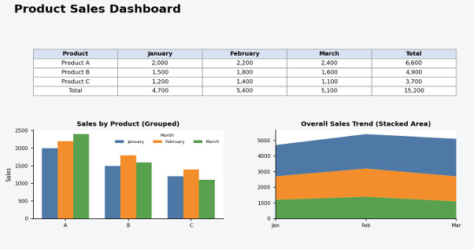
Observation:
The dashboard shows the product comparison, the overall sales trend and the sales table together.
Procedure
1. Define the sales values for each product and month in R as a matrix and a data frame. 2. Usebarplot() with beside = TRUE to create the grouped bar chart of first quarter sales. 3. Arrange the data in long format and use ggplot2 with geom_area() to draw the stacked area chart.
4. Createa dataframeof the monthly sales, add a Total column, and display it with print() and colSums().
5. Load the sales file into Tableau, pivot the month columns, and build the grouped bar chart, stacked area chart and table worksheets.
6. Combinetheworksheets in a Tableau dashboard and add filters and actions for interactivity.
RESULT:
The monthly product sales data was successfully analyzed using a grouped bar chart, a stacked area chart and a sales table in R. An interactive Tableau dashboard was also created, combining all three views so that users can explore the sales data by product and by month.

